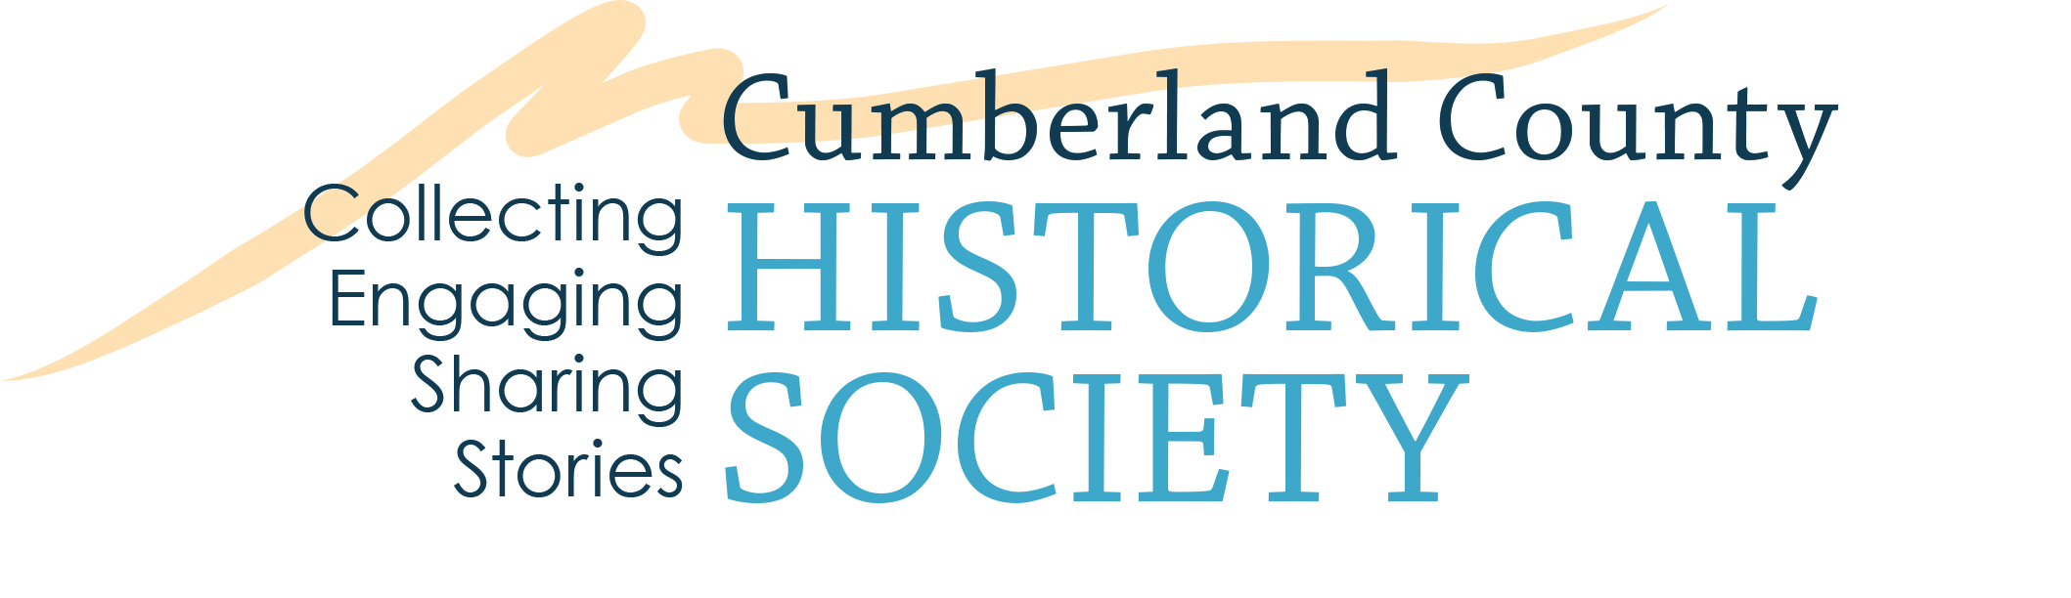

CCHS INTERNSHIP APPLICATION

Name: ________________________________________________

Email: ______________________________

Phone (the best number to reach you):_________________________

Permanent Address: _______________________________________________

College/University: ________________________________________________

School Address: __________________________________________________

Send correspondence to: (check one)
Permanent Address _____ School Address _____

Major(s): _______________________________________

Minor(s): _______________________________________

GPA: _______ Desired Number of Credits: ________

Number of Total Hours: ________

The internship will be taken for: (check one)
Credit ________ Non-Credit ________

Proposed Internship Dates:

Starting:__________________________ Ending: _______________________

Internship Advisor/Phone Number (if applicable):_______________________________

Days Interested in Working at CCHS: M T W Th F

Desired Hours at CCHS: ____________________

How did you learn about CCHS? ____________________________________

Additional Information:

Emergency Contact/Phone: __________________________

Medical Information: _______________________________

Physical Limitations: _______________________________

Please include one letter of recommendation or endorsement and on a separate sheet of paper, briefly describe any education or work experiences that may relate to your area(s) of interest at CCHS. Additionally, what do you hope to achieve from interning at CCHS?

Send completed application and related materials to:

Cumberland County Historical Society
21 N. Pitt St.
Carlisle, PA 17013
Attn: CCHS Internship Program

Or email to jillari@historicalsociety.com

Signature: _______________________________ Date: ___________________

For office use only:

Application and Related Materials Received: (Date) ____________
Interview Conducted: ____________
Orientation: _____________
Internship Information and Opportunities

Mission and Goals: The purpose of the Society is to collect, preserve, interpret and promote research of the history of Cumberland County, Pennsylvania. Working with individuals, organizations and agencies interested in the history of the county, the Society:

- Maintains a research library and a historical museum with collection accessible to the public.
- Collects and preserve public and private documents, books, records, photographs and artifacts of historical value.
- Assists historical research.
- Publishes source materials, the results of historical inquiry and information about the Society and others related to county history.
- Creates public awareness of the historical heritage of the county through education and outreach programs.
- Promotes the public and private preservation of buildings, structures and artifacts of historical value.
- Raises and administer funds for the purpose of the Society.

Brief Description of CCHS: Local history is replete with events, people, places and objects that have helped to shape not only local history but also the history of our state and nation. Understanding and appreciating our past can help us to understand the world we live in today. When visitors walk through the doors at the CCHS, they are provided with an important link to the past. They come in contact with artifacts and documents, real and convincing, that tell the stories of evolving lives, a changing world and the ideas and dreams that shaped our country. The objects and records give us a sense of continuity—of where we have been and how far we can go—our past is indeed our present and a prologue to our future. Since 1874 the CCHS has played an important role in making Cumberland County a special place to work and live.

As one of the first county historical societies established in Pennsylvania, the CCHS serves as a nonprofit organization that operates a museum and library designed to interpret the heritage of Cumberland County. The historical society contains a large photo collection and has several published works. Much of the research being done involves the Carlisle Indian School.

Internship Program: Internships provide structured learning experiences scheduled within a specific timeframe. The experience should be relevant to the intern’s academic and professional goals. Internships are performed under the direction of staff. Projects are determined based on the interests of the student and the needs of the CCHS.

Applicants are evaluated on a variety of factors including their academic standing, scholarly qualifications, experiences, proposed study/interests, and suitability to CCHS collections, faculties and programs. Internships are issued through a rolling application process.

Internship Requirements: During the time of their service, interns must currently be enrolled at an academic institution and possess a minimum cumulative GPA of 2.5. It is highly preferred that interns be interested in history, museums, education or other related subjects.

Internships at the CCHS is often taken for academic credit. However, non-credit internships are also available and involve the same application process. Interns usually serve for anywhere between three to six months and the position is non-stipend.

*Note: Each student is encouraged to consult with his/her corresponding internship advisor at his/her college/university to determine the number of credits appropriate for his/her individual academic requirements/needs.

Brief Description of CCHS Programs:

The Cumberland County Historical Society, founded in 1874, is dedicated to collecting, preserving and interpreting the rich history of Cumberland County. The Society maintains a library, archives, museum and lecture hall on North Pitt Street and the Two Mile House in South Middleton Township. The CCHS has over 15,000 visitors annually, 1,500 members and 220 volunteers.

We are engaged in a variety of activities such as:

Museum. The award-winning museum galleries provide visitors with a glimpse of early life and crafts. Visitors see furniture, silver, tools, redware, pottery, ironware, painted plank-bottom chairs, tall-case clocks. samplers, coverlets, and paintings produced by local artisans. Particularly noteworthy are the Schimmel and Mountz woodcarvings and the materials from the Carlisle Indian Industrial School.

Library. The library contains books, pamphlets, city directories, maps, tax lists, county records, newspapers, census records, genealogical materials, and manuscripts embracing all aspects of county history. Approximately 500,000 photographs add an important visual element to the collection. The Society’s manuscript collection is the 6th largest manuscript collection in Pennsylvania.

Programs. Gallery talks, evening lectures, educational forums, out-reach lectures, teachers' in-services, volunteer workshops and walking tours are offered throughout the year. Programs for all ages are offered throughout the year.

Publications. Publishing has been a hallmark of the Society since its founding. In addition, we offer the membership two award-winning history journals plus three newsletters annually.

Educational Program & G.B. Stuart History Workshop. An educational program with the county's school districts has provided local history lessons to over 18,000 students each year. CCHS has become a significant local resource for school teachers and students. We offer workshops and in-services for teachers, history camps and History Day mentoring workshops.

Two Mile House. The CCHS also owns and operates the Two Mile House, a property on the National Register of Historic Places. It is the site of the annual McLain Celtic Festival.

Health and Accidents: Interns who are not feeling well should not come in for their assignment but should call CCHS and make their advisor aware. If an intern sustains injury while on site, report it immediately to a staff member.

Appearance: Intern attire should confirm to the standards required of all staff: professional and comfortable. Some assignments, such as organizing storage, allow for more leisurely wear. Other assignments may require more stringent guidelines, such as minimal jewelry when working with collections.

Ethics: All interns are expected to adhere to the professional code of ethics applicable to the assignments.

Confidentiality: From time to time, interns have access to or may overhear information about CCHS, donors, members or visitors that deserve respect as to the right of privacy. Only when required in fulfillment of an assignment should any such information be discussed and that discussion should be done in a discrete manner and in a location where it cannot be overheard. Interns are to refrain from seeking information that is not needed in order to fulfill their assignments.

Conduct: All interns are expected to be polite and courteous, exhibiting a friendly and professional manner in all communications.

Benefits to a CCHS Internship:

- Satisfaction of contributing to the preservation and sharing of Cumberland County history and heritage.
- Gaining a unique, hands-on professional working experience that the classroom cannot provide.
- Developing an understanding of how nonprofit organizations operate.
- Improving necessary skills such as research, archival skills, curatorial experience, etc.
- Possible earning of college credit
- Employment marketing
CCHS Internship Procedures Supervisor Checklist (for CCHS):

_____ 1. Interns should have completed the application provided on the website and submitted the necessary materials.

_____ 2. Supervisors should interview the intern, discuss and review their assigned project(s) and requirements with them, and take them on a tour of the facility.

_____ 3. If applicable, remind interns that they should arrange to receive academic credit from their university and they are expected to clearly understand the requirements and necessary paperwork that is required by the school.

_____ 4. Interns should be given a nametag, an orientation to the Society, and be introduced to volunteers and staff of all departments.

_____ 5. Interns should take a museum tour with a docent, visit the Two Mile House, and should attend some meetings of the Society (staff, committee, etc.), and be invited to staff and volunteer functions.

_____ 6. Interns should be given the opportunity to learn the variety of tasks performed with the department, as well as have an opportunity to observe other departments while working at the Society.

_____ 7. Supervisors should function as mentors, providing information on further education and careers in museum/library/archive/public history fields, etc.

_____ 8. Supervisors should communicate often with interns and complete mid-term and final evaluations and an exit interview.

